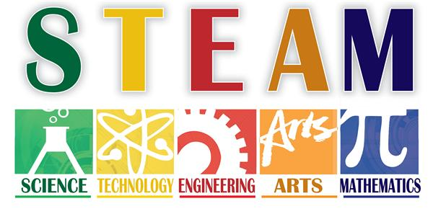

P.S./I.S. 192 STEAM Newsletter
December 2018
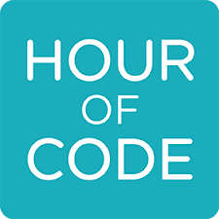
Hello Students and Staff!
We hope everyone had fun celebrating Computer Science week! Students in and out of the STEM Lab engaged in Hour of Code. This time was spent learning about the importance of Coding and Programming, through unplugged and plugged activities. We hope you enjoy catching up on all we’ve done this month. Bye for now!
-STEAM Committee
K-209 Students learned about how Engineers build different structures using different materials. They worked in groups to build their own designs!  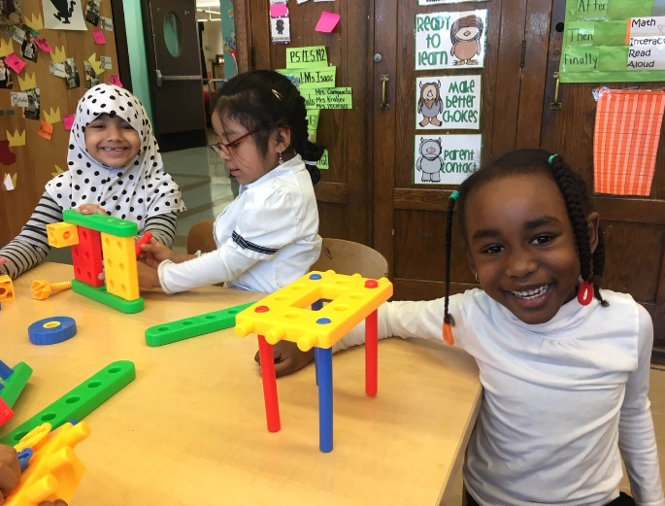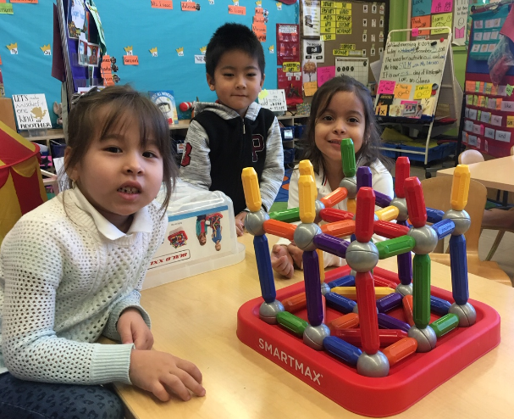 |  | STEM Cluster  Students engaged in Computer Science week this month! They worked on “Dance Party” through code.org to create animations using songs and dance moves.  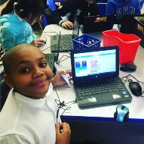  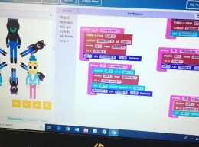  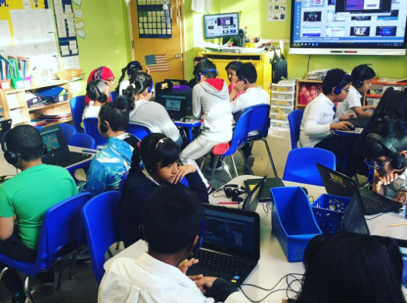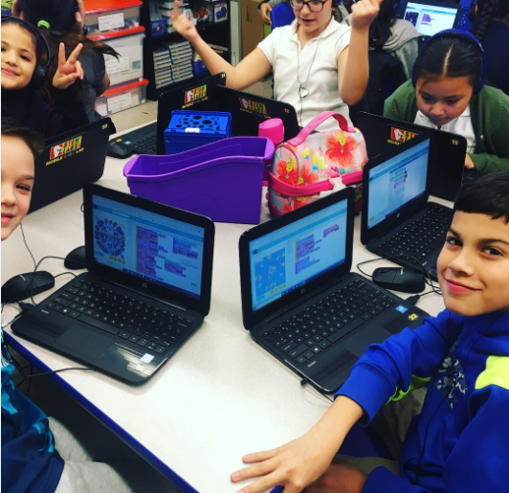

Parents Engaged in Hour of Code! Parents attended our first Coding Empowerment Activity on Tuesday December 4, 2018. They worked with their children to learn about Computer Science. Some of the centers included: code.org, Scratch, Kodable, and Robot Mouse.

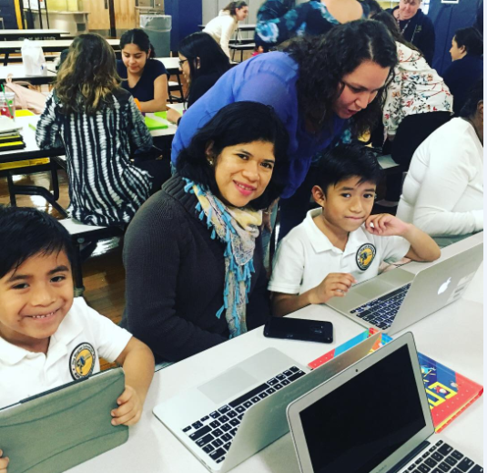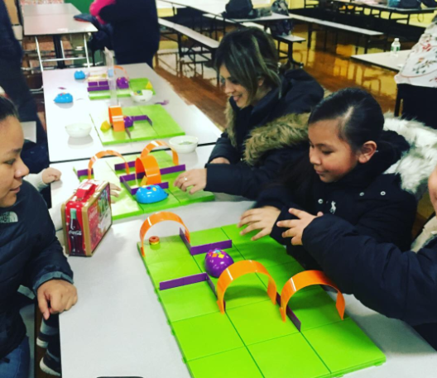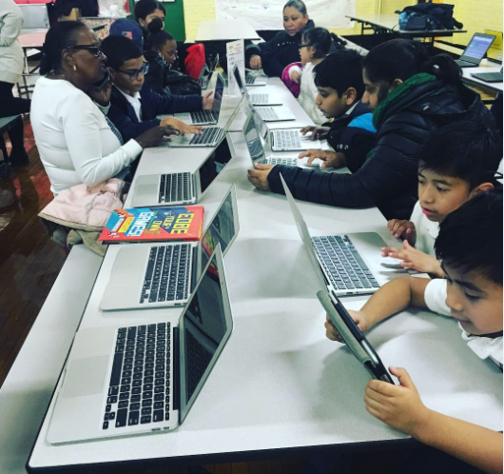

  - Grades K-8 engaged a variety of Coding Activities during Computer Science Week. We held two Kick-off Assemblies for Grades K-2 and 3-8. Besides activities done in their classrooms, students also had the opportunity to engage in coding activities in STEM Class and in Music and Movement. See all the classroom activities on the next page!
Class | Hour of Code Activity | Plugged/  Unplugged
K-211 | K211 worked together to code the pirate to find the treasure chest. Students worked in groups and were successful in finding the treasure. | Unplugged
K-213 | K213 worked together to understand that coding is using commands to move another object. The class played a game that allowed the students to move throughout the classroom first and then tried it on the computer. | Plugged and unplugged
1-305 | Code Monkey: Students used and solved challenges to figure out paths to get the bananas.  Code Dancing: Class created a dance using symbols | Plugged and unplugged
1-313 | Brain Pop Jr: Explanation of coding.  Code Monkey: the class designed a code and followed the corresponding steps. | Plugged
2-301 | Code Monkey: Students used and solved challenges to figure out paths to get the bananas.  Code Dancing -Students created 4 symbols and 4 movements and then created routines using more than 5 but less than 12 symbols. | Plugged and unplugged
2-307 | Kodable and Brainpop: Students along with their teachers, used Brainpop to program the character through a game. Students used ipads and computers to code using Kodable.  - Students created a code to “program” the teacher, Ms. DiMartino to walk around the classroom to get to a student. | Plugged and Unplugged
2-309 | Coding Vocabulary: Students were engaged in an activity where they were introduced to the terms programmer, code, and sequence. They had to then use these codes to write a complete code in sequence to unfreeze a robot (which was selected students.) The robot (student) stood in the front of the room, teacher told the students where we wanted the robot to move to in the room, and the students were responsible for writing a code in sequence to move the robot to this location. The class tried out several of the student’s codes, and several different students got the opportunity to be the robot. | Unplugged
3-303 | Hello Ruby: Students worked in stations to create:  - A Youtube video board on paper  - A remote control with buttons to make something, “do”  - A “design” of what the internet looks like  - an emoji story | Unplugged
3-311 | Gingerbread Coding: Students built a path from the Gingerbread person to the gingerbread house using a block code to move the gingerbread person around the board. | Unplugged
4-503 | Students used algorithms to code their own dancers. | Plugged
4-509 | -Students figured out how to guide one another to accomplish specific tasks without discussing them by using a predefined “Robot Vocabulary”  -Groups created algorithms for how the robot (student) should build the selected cup stack. | Unplugged
5-508 | Students worked in pairs or trios to participate in coding activities such as scratch, dance party, and code.org | Plugged
6-411 | Code.org: Dance Party  Computer scientists created a dance party by using coding and algorithms. | Plugged
6-412 | Star Wars: Students learned how to code by programming RD-D2 to progress through the stages of the game. | Plugged
7-409 | Binary Coding Bracelet: Class completed a code activity: “Binary Baubles”. Students learned about coding and binary codes. Then they coded their names and created bracelets using the codes. | Unplugged
8-512 | Students learned about binary codes. It is how computers communicate. Students demonstrated what they learned by sending letters to their favorite teachers in binary code. | Unplugged
STEM Cluster | Grades 2, 3, 5: Code.org: Course A, B, or C (Projects in the Sprite Lab)  Grades 6 and 7: Code.org: “Dance Party”/Lego/Little Bits  Grade 8: Create.mouse.org “Jingle Jam”/Code.org: Dance Party | Plugged

